APPENDIX2 - Diagram of Receptor Activation

A diagram showing how the acid-base, two-state model would produce receptor activation:
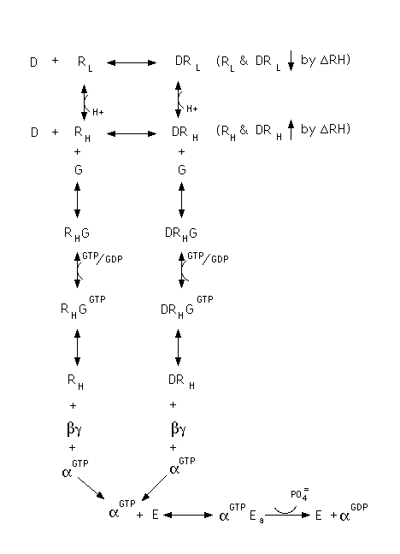

Where D is the binding ligand and R_{H} and R_{L} are the states of the receptor corresponding to the high and low affinity states respectively. G is the G protein and E is the enzyme within the cell that is activated by the alpha subunit of the G protein. ∆RH represents the shift produced by the relative unequal binding of D to R_{H} and R_{L}, which produces the response.

